

The Presidency of the Council of the European Union
General Secretariat of the Council
Rue de la Loi, 175
1048 Brussels
Belgium

Geneva, 26 February 2026
Mr. President,
The Geneva International Peace Research Institute (GIPRI) expresses its serious concern about violations by the Council of the European Union (CEU) of the rights to freedom of opinion, expression, research, information, movement and due process of at least six European nationals and their families since May 2025. These rights are enshrined in European Charter of Fundamental Rights, European Convention on Human Rights and Fundamental Freedoms, Article 2 of the Treaty of Lisbon, numerous United Nations conventions including the International Covenant on Civil and Political Rights (ICCPR) and the International Covenant on Economic, Social and Cultural Rights (ICESCR). These rights and liberties are part of the “aims and core values” of the European Union, which include human dignity, freedom, democracy, equality, rule of law, human rights.
GIPRI believes that si vis pacem, cole iusticiam (“if you want peace, cultivate justice”). The EU, holder of the Nobel Peace Prize, is now promoting war in Ukraine and is supporting the genocide in Palestine. Through Resolution 2202 of 2015, the Security Council unanimously supported the Minsk agreements the implementation of which would have prevented the military intervention of Russia in Ukraine. The Russian proposals of December 2021 were rejected by the West although they were in accordance with Art.1 §1 of the UN Charter “to take effective measures for the prevention and removal of threats to the peace.”
On 8 October 2024 the CEU adopted Regulation (EU) 2024/2642 instituting “restrictive measures” (i.e. sanctions) against persons accused of being involved in “destabilizing activities” in Europe on behalf of the Russian Federation. It deemed them “responsible for, implementing, supporting, or benefitting from actions or policies by the Government of the Russian Federation which undermine or threaten democracy, the rule of law, stability or security in the Union (…)”.
Implementing that regulation since May 2025 the CEU has sanctioned at least six citizens of the EU and other European countries: Swiss retired army colonel and geopolitical analyst Jacques Baud; Swiss anti-colonial advocate Nathalie Yamb; French Russian businessman and geopolitical analyst Xavier Moreau; and German journalists Huseyin Dogru, Alina Lipp and Thomas Röper.
These persons are sanctioned solely for their opinions, statements, articles or analysis which differ from the foreign policy of their government or the European Union. Their views, expressed in publications, at conferences, or in various media, have included critical assessments of the war in Ukraine, its roots, causes and consequences; analysis of US, NATO, EU and Russian politics in that conflict, and other important issues of international relations and geopolitics, involving war and peace. Their views were deemed “pro-Russian” by the CEU because they may have at times coincided with positions or policies of the Russian Federation. That the expression of opinions that may coincide with those of a state designates, in the eyes of the CEU, their locutor as an agent, supporter or sympathizer of that state, is a serious concern.
Their views reflect their personal beliefs and convictions. They are shared by prominent US and other professors such as John Mearsheimer (University of Chicago) and Jeffrey Sachs (Columbia University). Even if they were wrong, the UN Human Rights Committee has asserted that there is a right to be wrong. That is what freedom of opinion and expression means.
This sanctioning has dire consequences for them and their families: it deprives them of their resources and means livelihood and amounts to a social and economic death sentence: they cannot access to their bank accounts any longer, and thus are unable to ensure their daily subsistence; they can’t receive salaries nor pay their rent, bills, or medical care and can’t even defend themselves against these sanctions, since this requires resources to hire a lawyer.
Anyone transferring or providing money to help them may face up to five years in prison. In addition, they have lost their right to freedom of movement inside the EU and are de facto assigned to residence in the country where they live: Belgium, Switzerland, France or Germany. Should they travel outside the EU, they would not be able to return home.
These persons are being punished for having peacefully exercised their rights to freedom of opinion, expression, research, information and movement. These rights are at the heart of European and international human rights law: the European Convention on Human Rights (ECHR), the EU Charter of Fundamental Rights (CFREU), the Universal Declaration of Human Rights (UDHR), the International Covenant on Civil and Political Rights (ICCPR) and the International Covenant on Economic, Social and Cultural rights (ICESCR). Thery are also part and parcel of the “aims and core values” of the EU, which include human dignity, freedom, democracy, equality, rule of law, human rights.
The CEU states that its sanctions are compliant with EU obligations under international law, including human rights and fundamental freedoms. And yet, they violate articles 9 and 10 of the ECHR; and Articles 10 11, 13 and 45 of the CFREU. They violate Articles 8, 10, 12, 13, 17, 18 and 19 of the UDHR; and articles 12, 18, 19, 26 of the ICPPR. The UN Human Rights Committee has stated in its general comment 34 that “all forms of opinion are protected, including opinions of a political, scientific, historic, moral or religious nature”. The peaceful public expression of an opinion cannot be a crime in a democratic environment, unless it incites to violence or hate. The text of these rights is appended to this letter.
These sanctions are politically motivated, arbitrary and extra-judicial. They are decreed outside any legal framework and violate the most basic principles of due process, in particular the rights to be presumed innocent, the principle of nulla poena sine culpa, the right to defend oneself against accusations, and the right to a fair hearing before an independent court. The also violate the right to non-discrimination for one’s opinions and constitute an attack on the honour and reputation of the person concern. Specifically, the sanctions violate ECHR’s articles 6, 7 and 13; articles 41, 47 and 48 of the CFREU; articles 8, 10 and 11 of the UDHR, and article 14 and 17 of the ICCPR.

They intend to pressure, intimidate and scare these persons, and through them to dissuade others – in particular journalists, researchers, academics - to freely express their views and to prevent them from producing information and participating in public debates about such important matters of public interest as national and international relations, war and peace. The UN Human Rights Committee has stressed that “the harassment, intimidation or stigmatization of persons for reasons of the opinions they may hold constitutes a violation of article 19, paragraph 1 of the ICCPR. Every effort to coerce the holding or not holding of any opinion is prohibited.
These sanctions intend to silence these persons or to force them to change their opinions. This is explicitly stated by the CEU, in an Orwellian twist of thought: “These sanctions are not punitive and instead seek to bring about a change in the policy or conduct of those targeted, with a view to promoting the objectives of the EU's Common Foreign and Security Policy”.
The Committee on Economic, Social and Cultural Rights has stressed the obligation of states to ensure “robust protection of freedom of research”, which includes “the protection of researchers from undue influence on their judgment; the possibility for researchers to set up autonomous research institutions and to define the aims and objectives of the research and the methods to be adopted; the freedom of researchers to freely and openly question the ethical value of certain projects and the right to withdraw from those projects if their conscience so dictates; the freedom of researchers to cooperate with other researchers, both nationally and internationally; and the sharing of scientific data and analysis with policymakers, and with the public wherever possible”.
These sanctions undermine academic freedom, which “protects the ability of individuals to question and test received knowledge, to think outside conventional ideas and received opinions and to propose new concepts, including controversial or unpopular opinions, for the benefit of societies.” The Human Rights Council has highlighted that “members of academic communities (…) should be free to conduct activities involving the discovery and transmission of knowledge and ideas, and to do so with the full protection of human rights law.”
According to ICCPR’s Article 19 the only limitations to freedom of expression, academic and scientific freedoms, are those deemed necessary for the respect of the rights or reputations of others or for the protection of national security or public order, with the burden of proof of the necessity and proportionality of such restrictions lying strictly with the State. Can the EU explain in what way the views expressed by these persons undermine EU’s national security or public order? The Human Rights Committee has explicitly stated that research that does not harm national security or public order may not be suppressed. In its jurisprudence it has times and again rejected the abuse of the concept of “national security” by States and reaffirms the imperative to respect freedom of opinion and research as a crucial component of democracy.
Last but not least, we understanding that any unilateral sanctions decreed by states or groups of states, outside the framework of the United Nations Security Council, are illegal and prohibited under international law.
These sanctions is an intolerable form of censorship. If allowed to continue, it is the very edifice of our political and civic space that has taken several centuries to be built, often at very high price, that is undermined. We are all concerned.
Through these attacks against freedom of expression, it is every European’s right to information and to benefit from the result of independent research which is arbitrarily restricted. On what grounds can the EU dictate what information is right or wrong? Are we unable to use our critical faculties to discern truth from falsehood and need a Ministry of Truth to direct our conscience and tell us what to think? In the EU today are we allowed to question, to doubt and to think?
Under international human rights law, we do have the right to access any information and opinion which we deem necessary to form our own judgement on any matter important to us and are determined to defend this right.
Premising itself on international human rights law, which is at the foundation of the EU and the UN, we are contesting the legality and legitimacy of these sanctions.
We urge the CEU to rescind these decisions and restore the rights and freedoms to which these persons are entitled under European and international law. We also urge the members of the European Parliament to remind the Council of the EU of its obligations to effectively protect the rights to freedom of opinion, expression, information, movement and due process of these persons, which are the corner stones of the rule of a just law, of a healthy democratic process, and which are conducive to dignity, justice and peace.
We would welcome a response to this letter and reserve our right to disseminate and publish it should we deem it necessary to protect our individual and collective rights and freedoms.

Yours sincerely,

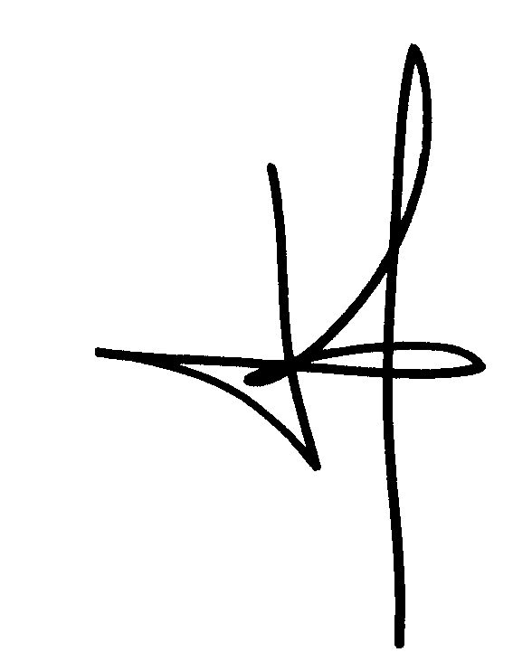

Dr Gabriel Galice
President

GIPRI
Clos Mallet-du-Pan 6,
1208 Genève
Suisse

Aims and values of the European Union : https://european-union.europa.eu/principles-countries-history/principles-and-values/aims-and-values_en
Article 2(3)(a)(iv), https://eur-lex.europa.eu/eli/reg/2024/2642/oj/eng.
https://eur-lex.europa.eu/legal-content/EN/TXT/?uri=CELEX%3A02024R2642-20251007.
UN Human Rights Committee, General Comment 34 on ICCPR article 9 on liberty and security of persons.
Aims and values of the European Union : https://european-union.europa.eu/principles-countries-history/principles-and-values/aims-and-values_en
https://docs.un.org/en/CCPR/C/GC/34, para. 9.
Human rights Committee, General Comment 34, ibid.
Ibid., para. 10.
https://www.consilium.europa.eu/en/policies/why-sanctions/
Ibid.
https://docs.un.org/en/A/HRC/56/58, para. 2.
https://docs.un.org/en/A/HRC/RES/59/9.
Human Rights Committee, general comment No. 34 (2011), para. 30.
HRC, resolution 15/24 of 6 October 2010, paras. 1-3; HRC, resolution 45/5 of 6 October 2020, preamble; HRC, resolution 49/6 of 31 March 2022, preamble, paras. 1-3; HRC, resolution 52/13 of 17 April 2023, paras. 1-6; HRC, resolution 55/7 of 5 April 2024, paras. 1-6; HRC, resolution 58/3 of 2 April 2025, paras. 1-7; UNGA, resolution 69/180 of 18 December 2014, paras. 5-6; UNGA, resolution 75/181 of 16 December 2020, paras. 1-6; UNGA, resolution 76/161 of 7 January 2022, paras. 1-6; UNGA, resolution 77/214 of 5 January 2023, paras. 1-6; UNGA, resolution 78/202 of 23 December 2023, paras. 1-6; UNGA, resolution 79/167 of 17 December 2024, paras. 1-6. UNGA, resolution 80/209 of 18 December 2025. See also ARRIA Formula discussion of unilateral coercive measures before the UN Security Council, 25 March 2024.

